Exception Handling in Java

1. What is an Exception?
An exception is an unexpected event that occurs during the execution of a program and interrupts its normal flow.

2. Why Do We Need Exception Handling?
Exception handling allows us to:
- Handle runtime errors.
- Prevent abnormal termination of programs.
- Display meaningful error messages.
- Continue program execution when possible.
- Separate error-handling code from normal program logic.

Real-Life Example:
Consider an ATM.
If a user tries to withdraw more money than their account balance, the ATM should not crash.
Instead, it should display:
Insufficient balance.
Please enter a valid amount.
This is similar to exception handling in Java.

3. Types of Exceptions
Java exceptions can broadly be classified into:
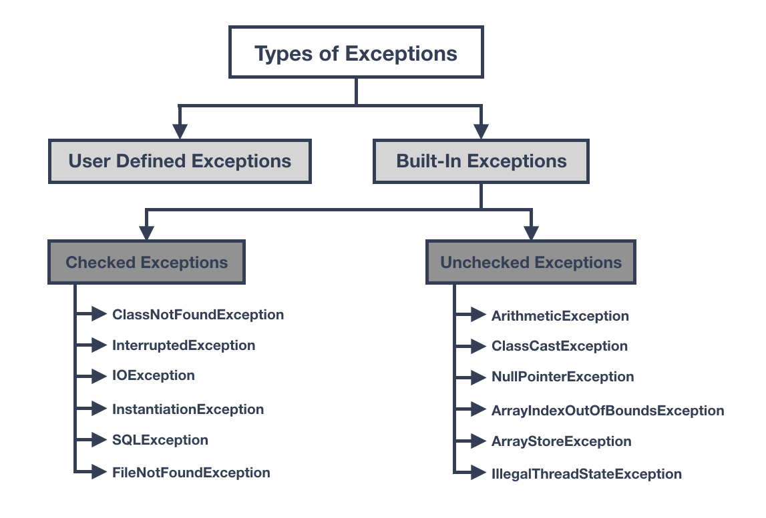

4. try-catch
The try-catch block is used to handle exceptions.

Syntax
try {
// Code that may cause exception
}
catch (ExceptionType e) {
// Code to handle exception
}

Example

public class AException {

public static void main(String[] args) {

try {
int result = 10 / 0;

System.out.println(result);
}
catch (ArithmeticException e) {
System.out.println("Cannot divide by zero.");
}

System.out.println("Program continues...");
}
}

Output
Cannot divide by zero.
Program continues…

How it works:
try
↓
Exception occurs
↓
catch
↓
Exception handled
↓
Program continues

5. Using Exception Object
The catch block receives an exception object.
catch (ArithmeticException e)
Here:
- ArithmeticException = type of exception
- e = reference to the exception object
We can use methods such as:
e.getMessage()
and
e.printStackTrace()

Example:
public class Main {

public static void main(String[] args) {

try {

int result = 10 / 0;

System.out.println(result);

}
catch (ArithmeticException e) {

System.out.println("Error: " + e.getMessage());
}
}
}

Output
Error: / by zero

6. Multiple Catch Blocks
A program may have different types of exceptions.
We can use multiple catch blocks.

Example
public class MultiException {

public static void main(String[] args) {

try {

int[] numbers = {10, 20, 30};

System.out.println(numbers[5]);

}
catch (ArithmeticException e) {

System.out.println("Arithmetic error occurred.");

}
catch (ArrayIndexOutOfBoundsException e) {

System.out.println("Array index is out of range.");
}
}
}

Output
Array index is out of range.
Java executes the catch block that matches the exception type.

7. finally
The finally block contains code that is generally executed whether an exception occurs or not.

Syntax
try {
// Risky code
}
catch (Exception e) {
// Handle exception
}
finally {
// Code that should execute afterward
}

Example
public class FinallyEg {

public static void main(String[] args) {

try {

int result = 10 / 2;

System.out.println("Result: " + result);

}
catch (ArithmeticException e) {

System.out.println("Cannot divide by zero.");

}
finally {

System.out.println("Finally block executed.");
}
}
}

Output
Result: 5
Finally block executed.

8. Example: finally with Exception
public class FinallyWithEg {

public static void main(String[] args) {

try {

int result = 10 / 0;

System.out.println(result);

}
catch (ArithmeticException e) {

System.out.println("Exception handled.");

}
finally {

System.out.println("This block always executes.");
}
}
}

Output:
Exception handled.
This block always executes.

Common Use of finally
finally is commonly used for cleanup operations such as:
- Closing files
- Closing database connections
- Releasing resources

9. throw Keyword
The throw keyword is used to explicitly create and throw an exception.

Syntax
throw new ExceptionType("Message");

Example
public class ThrowEg {

public static void main(String[] args) {

int age = 16;

if (age < 18) {

throw new IllegalArgumentException(
"Age must be 18 or above."
);
}

System.out.println("Eligible to vote.");
}
}

Output:
Exception in thread "main" java.lang.IllegalArgumentException: Age must be 18 or above.
Here we manually throw the exception using:
throw new IllegalArgumentException(...)

10. throw with try-catch
We can also handle the manually thrown exception.
public class ThrowswithTry {

public static void main(String[] args) {

int age = 16;

try {

if (age < 18) {

throw new IllegalArgumentException(
"Age must be 18 or above."
);
}

System.out.println("Eligible to vote.");

}
catch (IllegalArgumentException e) {

System.out.println("Error: " + e.getMessage());
}

System.out.println("Program continues...");
}
}

Output
Error: Age must be 18 or above.
Program continues...

11. throws Keyword
The throws keyword is used in a method declaration to indicate that a method may throw one or more exceptions.

Syntax
returnType methodName() throws ExceptionType {

}

Example
public class Main {

static void checkAge(int age) throws Exception {

if (age < 18) {

throw new Exception("Age must be 18 or above.");
}

System.out.println("Eligible.");
}

public static void main(String[] args) {

try {

checkAge(16);

}
catch (Exception e) {

System.out.println("Error: " + e.getMessage());
}
}
}

Output
Error: Age must be 18 or above.

12. Difference Between throw and throws
This is an important interview and examination question.
throw | throws
Used to explicitly throw an exception | Declares that a method may throw an exception
Used inside a method/block | Used in method declaration
Throws one exception at a time | Can declare multiple exceptions
Followed by an exception object | Followed by exception class names

Example
throw:
throw new Exception("Something went wrong");
throws:
static void test() throws Exception {

}

13. User-Defined Exceptions
Java allows programmers to create their own exceptions according to application requirements.
These are called User-Defined Exceptions or Custom Exceptions.
For example, Java already provides:
ArithmeticException
NullPointerException
ArrayIndexOutOfBoundsException
But suppose we are creating a banking application and need:
InsufficientBalanceException
We can create our own exception class.

14. Creating a User-Defined Exception
A custom exception can be created by extending the Exception class.

InsufficientBalanceException.java
public class InsufficientBalanceException extends Exception {

public InsufficientBalanceException(String message) {

super(message);
}
}
Here:
extends Exception
means that our class is an exception.
The:
super(message);
passes the message to the parent Exception class.

15. Using User-Defined Exception

public class Insufficientbalance {

static void withdraw(double balance, double amount)
throws InsufficientBalanceException {

if (amount > balance) {

throw new InsufficientBalanceException(
"Insufficient balance."
);
}

balance = balance - amount;

System.out.println(
"Withdrawal successful."
);

System.out.println(
"Remaining balance: " + balance
);
}

public static void main(String[] args) {

double balance = 5000;
double amount = 7000;

try {

withdraw(balance, amount);

}
catch (InsufficientBalanceException e) {

System.out.println(
"Transaction failed: " + e.getMessage()
);
}
}
}

Folder Structure
Keep both files in the same folder:
JavaProject
│
├── Main.java
└── InsufficientBalanceException.java

Compile
Open the VS Code terminal:
javac Main.java InsufficientBalanceException.java

Run
java Main

Output
Transaction failed: Insufficient balance.

Concept | Purpose
try | Contains code that may cause an exception
catch | Handles the exception
finally | Executes cleanup/final code
throw | Explicitly throws an exception
throws | Declares possible exceptions from a method
Custom Exception | Programmer-defined exception

Example Structure
try {

// Risky code

}
catch (Exception e) {

// Handle exception

}
finally {

// Cleanup code
}

try:
Used to identify code that may produce an exception.

catch:
Used to handle the exception.

finally:
Used for code that should execute after the try/catch process, commonly for cleanup.

throw:
Used when the programmer wants to explicitly generate an exception.

throws:
Used to declare exceptions that a method may pass to its caller.

User-Defined Exception:
Created by extending Exception or another appropriate exception class.

Assignment 7 : E-Commerce Coupon Validator
Develop a Java program for an E-Commerce Coupon Validation System.
The program should accept the order amount and coupon code from the user and validate the coupon based on the following rules:
- SAVE10 → Minimum order ₹1,000 → 10% discount
- SAVE20 → Minimum order ₹2,000 → 20% discount
- SAVE30 → Minimum order ₹3,000 → 30% discount

Requirements
- Create a user-defined exception named InvalidCouponException.
- Use throw to generate the exception when:
  - The coupon code is invalid, or
  - The order amount does not meet the minimum requirement.
- Use throws in the appropriate method.
- Handle the exception using try-catch.
- Use finally to display a message indicating that coupon validation is completed.
- For a valid coupon, display the discount amount and final payable amount.
- For an invalid coupon, display a meaningful error message without terminating the program.

import java.util.Scanner;

class InvalidCouponException extends Exception {

public InvalidCouponException(String message) {
super(message);
}
}

public class UDE {

static double validateCoupon(double amount, String coupon)
throws InvalidCouponException {

double discountRate;

if (coupon.equalsIgnoreCase("SAVE10")) {

if (amount < 1000) {
throw new InvalidCouponException(
"Minimum order amount for SAVE10 is ₹1000."
);
}

discountRate = 10;

} else if (coupon.equalsIgnoreCase("SAVE20")) {

if (amount < 2000) {
throw new InvalidCouponException(
"Minimum order amount for SAVE20 is ₹2000."
);
}

discountRate = 20;

} else if (coupon.equalsIgnoreCase("SAVE30")) {

if (amount < 3000) {
throw new InvalidCouponException(
"Minimum order amount for SAVE30 is ₹3000."
);
}

discountRate = 30;

} else {

throw new InvalidCouponException(
"Invalid coupon code."
);
}

double discount = amount * discountRate / 100;

System.out.println("\nCoupon applied successfully.");
System.out.println("Original Amount: ₹" + amount);
System.out.println("Coupon Code: " + coupon);
System.out.println("Discount: " + discountRate + "%");
System.out.println("Discount Amount: ₹" + discount);
System.out.println("Final Payable Amount: ₹" + (amount - discount));

return discount;
}

public static void main(String[] args) {

Scanner sc = new Scanner(System.in);

System.out.print("Enter order amount: ₹");
double amount = sc.nextDouble();

System.out.print("Enter coupon code: ");
String coupon = sc.next();

try {

validateCoupon(amount, coupon);

} catch (InvalidCouponException e) {

System.out.println("\nInvalid Coupon: " + e.getMessage());

} finally {

System.out.println("\nCoupon validation process completed.");
}

System.out.println("Program continues...");

sc.close();
}
}

File Handling in Java
File handling allows a Java program to create, read, write, update, and delete files stored on the computer.
Java provides several classes for file handling through the java.io package.

Important classes
Class | Purpose
File | Creates, checks, deletes, and provides information about files/directories
FileInputStream | Reads data from a file byte by byte
FileOutputStream | Writes data to a file byte by byte
FileReader | Reads character data
FileWriter | Writes character data
BufferedReader | Efficiently reads text
BufferedWriter | Efficiently writes text

1. File Class
The File class is present in:
import java.io.File;
It is used to represent a file or directory path.

Important point
The File class itself does not read or write the contents of a file.
It is mainly used for:
- Creating files
- Checking whether a file exists
- Getting file information
- Creating directories
- Deleting files
- Getting file paths

Important Methods of File Class
Method | Description
createNewFile() | Creates a new file
exists() | Checks whether file exists
getName() | Returns file name
getPath() | Returns path
getAbsolutePath() | Returns complete path
length() | Returns file size in bytes
isFile() | Checks whether it is a file
isDirectory() | Checks whether it is a directory
delete() | Deletes a file/directory
mkdir() | Creates a directory

Example 1: Creating and Checking a File
import java.io.File;
import java.io.IOException;

public class FileHEG{
public static void main(String[] args) throws IOException {

File file = new File("student.txt");

if (file.createNewFile()) {
System.out.println("File created");
} else {
System.out.println("File already exists");
}

System.out.println("Name: " + file.getName());
System.out.println("Path: " + file.getPath());
System.out.println("Size: " + file.length() + " bytes");
System.out.println("Exists: " + file.exists());
System.out.println("Is File: " + file.isFile());
}
}

Output
First execution:
File created successfully.
File Name: student.txt
File Path: C:\...\student.txt
File Size: 0 bytes
Is File: true
On running again:
File already exists.
A file named student.txt will be created in your project folder.

2. Checking Whether a File Exists
The exists() method returns either true or false.

import java.io.File;

public class CheckFile {

public static void main(String[] args) {

File file = new File("student.txt");

if (file.exists()) {
System.out.println("File exists.");
} else {
System.out.println("File does not exist.");
}
}
}

Output
File exists.

3. Deleting a File
import java.io.File;

public class DeleteFile {

public static void main(String[] args) {

File file = new File("student.txt");

if (file.delete()) {
System.out.println("File deleted successfully.");
} else {
System.out.println("File not found.");
}
}
}

4. Creating a Directory
The mkdir() method creates a directory.
import java.io.File;

public class DirectoryExample {

public static void main(String[] args) {

File folder = new File("StudentData");

if (folder.mkdir()) {
System.out.println("Directory created.");
} else {
System.out.println("Directory already exists.");
}
}
}

This creates:
StudentData
inside your current project folder.

5. File Input/Output Streams
Java provides streams for reading and writing data.
A stream can be thought of as a flow of data between the program and a file.

Two important streams
File
↑
│
FileInputStream
│
Java Program
│
FileOutputStream
│
↓
File

Input Stream
Used to read data from a file.
FileInputStream

Output Stream
Used to write data to a file.
FileOutputStream

6. FileOutputStream
FileOutputStream is used to write byte data into a file.
Import:
import java.io.FileOutputStream;

Basic syntax
FileOutputStream fos = new FileOutputStream("file.txt");
Then:
fos.write(data);
Finally:
fos.close();

Example 2: Writing Data to a File

import java.io.FileOutputStream;
import java.io.IOException;

public class WriteFile {

public static void main(String[] args) {

try {
FileOutputStream fos =
new FileOutputStream("student.txt");

String data = "Welcome to Java File Handling.";

fos.write(data.getBytes());

fos.close();

System.out.println("Data written successfully.");

} catch (IOException e) {
System.out.println("Error: " + e.getMessage());
}
}
}

Output
Data written successfully.
The student.txt file will contain:
Welcome to Java File Handling.

Important
data.getBytes()
converts the String into bytes because FileOutputStream works with byte data.

7. FileInputStream
FileInputStream is used to read byte data from a file.
Import:
import java.io.FileInputStream;

Basic syntax
FileInputStream fis =
new FileInputStream("student.txt");
Reading:
int data = fis.read();
Closing:
fis.close();

8. Writing and Reading a File in One Program
This is a very useful exam program.
Save as:
FileIOExample.java

import java.io.FileInputStream;
import java.io.FileOutputStream;
import java.io.IOException;

public class FileIOExample {

public static void main(String[] args) {

String fileName = "data.txt";

try {
// Writing data
FileOutputStream fos =
new FileOutputStream(fileName);

String message = "Java File Handling Example";

fos.write(message.getBytes());

fos.close();

System.out.println("Data written successfully.");

// Reading data
FileInputStream fis =
new FileInputStream(fileName);

int data;

System.out.println("Data from file:");

while ((data = fis.read()) != -1) {
System.out.print((char) data);
}

fis.close();

} catch (IOException e) {
System.out.println("Error: " + e.getMessage());
}
}
}

Output
Data written successfully.
Data from file:
Java File Handling Example

9. Append Data to an Existing File
By default:
new FileOutputStream("data.txt");
overwrites the existing contents.
To add data at the end of the file, use:
new FileOutputStream("data.txt", true);
The true means append mode.

Example

import java.io.FileOutputStream;
import java.io.IOException;
public class AppendFile {

public static void main(String[] args) {

try {
FileOutputStream fos =
new FileOutputStream("student.txt", true);

String data = "\nThis is additional information.";

fos.write(data.getBytes());

fos.close();

System.out.println("Data appended successfully.");

} catch (IOException e) {
System.out.println("Error: " + e.getMessage());
}
}
}

If the file originally contains:
Welcome to Java.
After execution:
Welcome to Java.
This is additional information.

10. Important Difference: File Class vs File Streams
File Class | File Streams
Represents a file/directory | Transfers data
Does not read file contents | Reads/writes file contents
Used for file information | Used for I/O operations
exists() | read()
createNewFile() | write()
delete() | close()
length() | Reads/writes bytes

Remember
File Class
↓
File management

FileInputStream
↓
Read data

FileOutputStream
↓
Write data

11. Exception Handling in File Handling
File operations may generate exceptions.
For example:
- File does not exist
- File cannot be accessed
- Permission problems
- Invalid file path
Therefore, file operations commonly use:
try-catch
or:
throws IOException
Example:
try {
FileInputStream fis =
new FileInputStream("data.txt");
}
catch (IOException e) {
System.out.println(e.getMessage());
}
IOException means Input/Output Exception.

12. Important Exam Points

File class
Remember these methods:
createNewFile()
exists()
getName()
getPath()
getAbsolutePath()
length()
isFile()
isDirectory()
delete()
mkdir()

FileOutputStream
Main methods:
write()
close()
Used for:
Writing bytes to a file.

FileInputStream
Main methods:
read()
close()
Used for:
Reading bytes from a file.

Most important concept
read()
returns -1 when the end of the file is reached.

13. How to Run in VS Code
Create a folder such as:
JavaFileHandling
Create:
FileIOExample.java
Open the VS Code terminal and run:
javac FileIOExample.java
Then:
java FileIOExample
You should see:
Data written successfully.
Data from file:
Java File Handling Example
The program will automatically create:
data.txt

